PICTURE STORY 1A

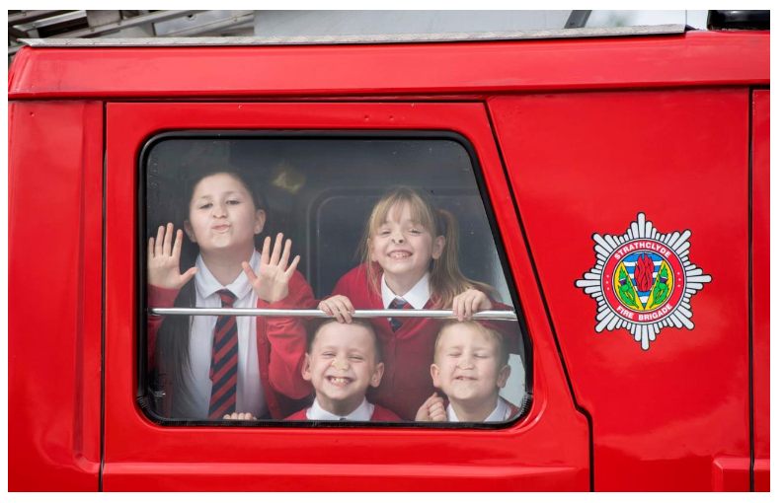

PICTURE STORY 1B



PICTURE STORY 2A



**S P E A K I N G – P I C T U R E S**

Make up a short speech using the pictures below. Try to think about the following questions:  
• What will people be able to buy in this type of shop?  
• What will be missing there?  
Support your opinion with some arguments.



**P I C T U R E – S T O R Y**

Based on the picture, create a story of a young athlete who had to overcome certain obstacles (in his personal life or sports career) to become successful.

